

**UNIVERSITY OF PETROLEUM AND ENERGY STUDIES**

**School of Computer** **Science**

**2020-21**

**GRAPHICS AND ANIMATION TOOLS LAB**

**Faculty: Dr. DURGANSH SHARMA**

**Assistant Professor**

**Department of Cybernetics.**

**School of Computer Science, UPES**

**Submitted By:**

**Name - Vartika Deep**

**SAP ID – 500062441**

**Course - B.Tech CSE(OS&OS)**

**Semester – VII**

**Batch - B3**

**Roll no. - R100217088**

**FINAL PROJECT**

**LANDSCAPE using Blender**

**STEPS:**

1. Go to Edit-Preferences-Select A.N.T Landscape and select lakes type.

2. Go to Edit-Preferences-Select Sapling trees add-on.

3. Add sphere to make a sun.

4. Add trees on the plane.

5. Select particular parts of the scene and color them one by one.

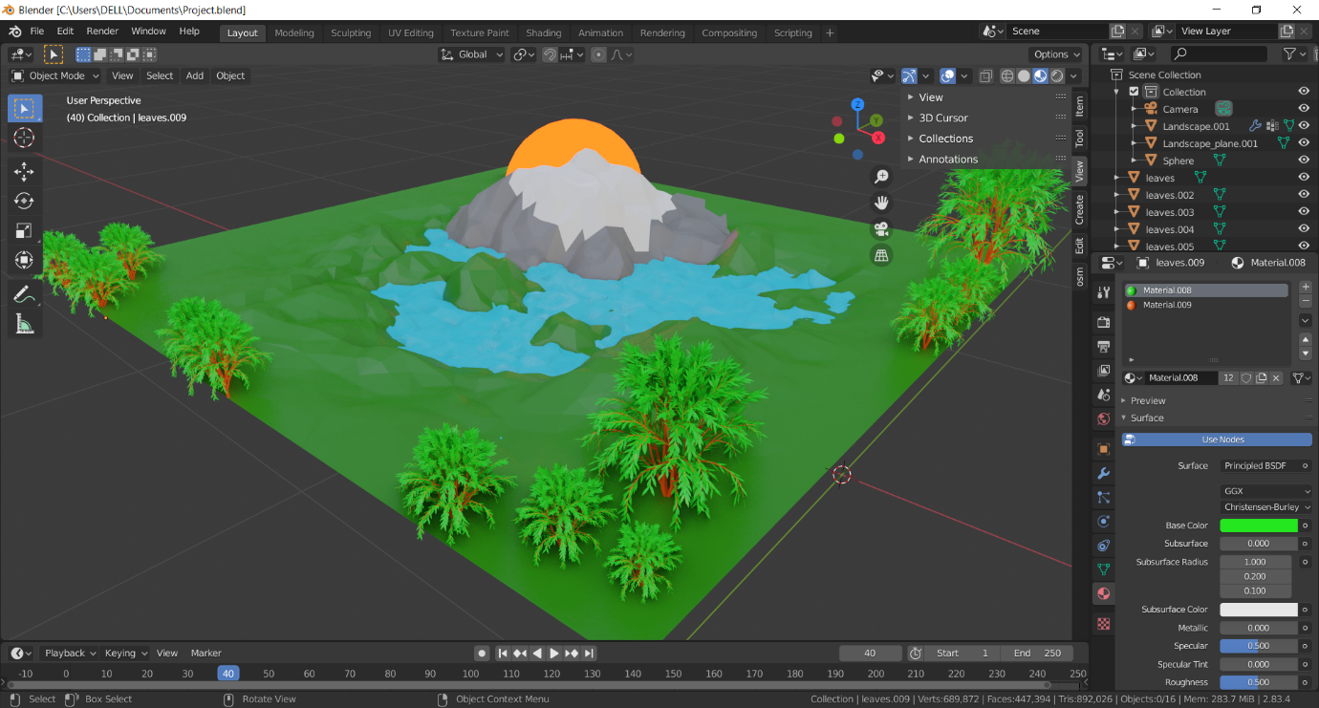

**Link :**

https://drive.google.com/file/d/1fug4e_A2KtyEBx6kr9h19UMWxwYucCB8/view?usp=sharing